MSURJ OJS Guide for Authors

Rectangle

This document outlines the general workflow for an author. There are several stages involved for authors, starting with Registering with the Journal and Submitting an Article. This guide will explain in detail what an author should do, and pay attention to, for each of these stages.

**Stage 1: Registering with the Journal**



In order to make your submission, you will first have to register a user account with the journal's OJS platform. To do this, click the Register link in the upper right corner. You will then have to fill out a Registration Form, in which you must fill every field with an asterisk. 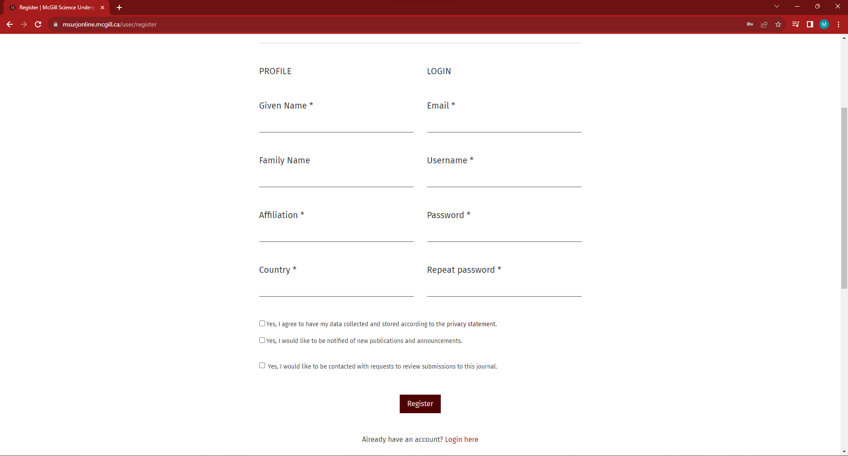

After you are approved, you can sign in on the website via the “Login” link in the top right:

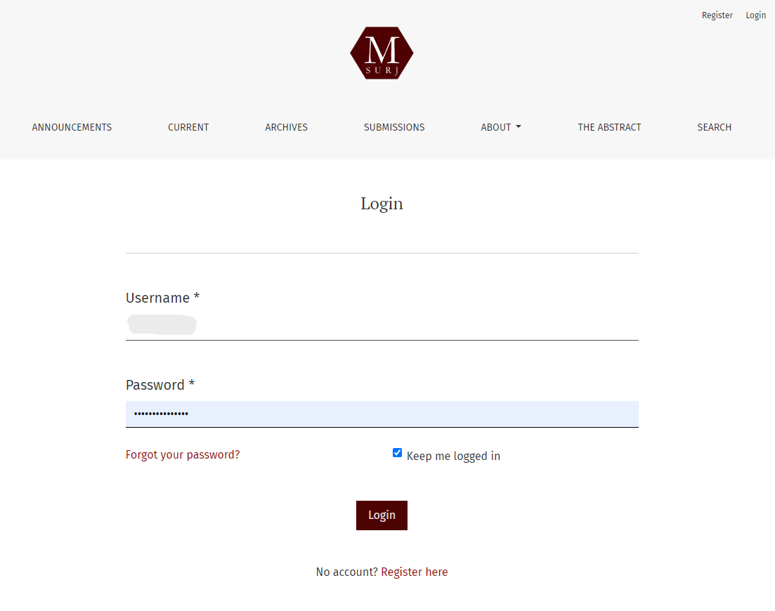

**Stage 2: Submitting an Article**

*View the below video for a more in-depth explanation on submitting your article.*

[Editorial workflow in OJS 3.3. Module 3: Submitting an Article](https://youtu.be/AJwDWdAu8BQ?si=fJR3JnTPJbr46-mo&t=76)

(link: <https://youtu.be/AJwDWdAu8BQ?si=fJR3JnTPJbr46-mo&t=76>)

Below is a summary of some of the steps described with images from MSURJ's interface.Start by clicking on the “Submissions” tab on the left in your OJS dashboard. Then, click on “New Submission” on the right side of the screen in the “My Queue” section. In this stage, you will have to complete a **five-step process** to upload and describe your submission.

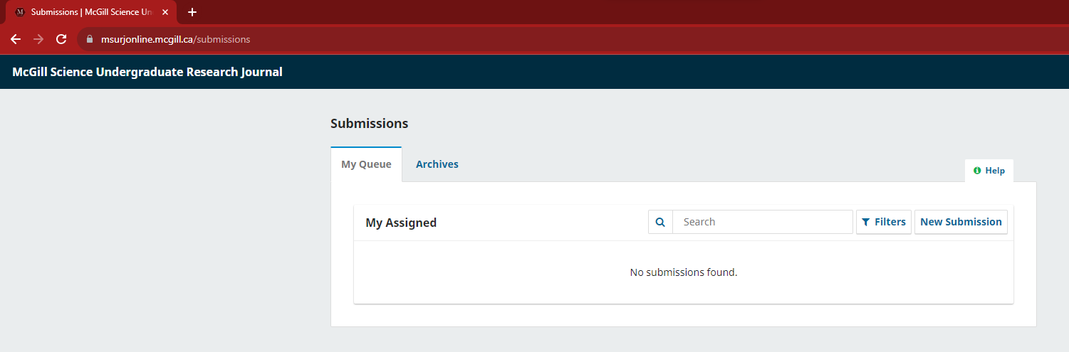

* Step 1: Start

The first step requires that you provide some initial information about your submission. This includes:

* Selecting whether your submission is a research article or a review article
* Including any extra comments to the editor.
* Reading and agreeing to the journal’s copyright and privacy statements.

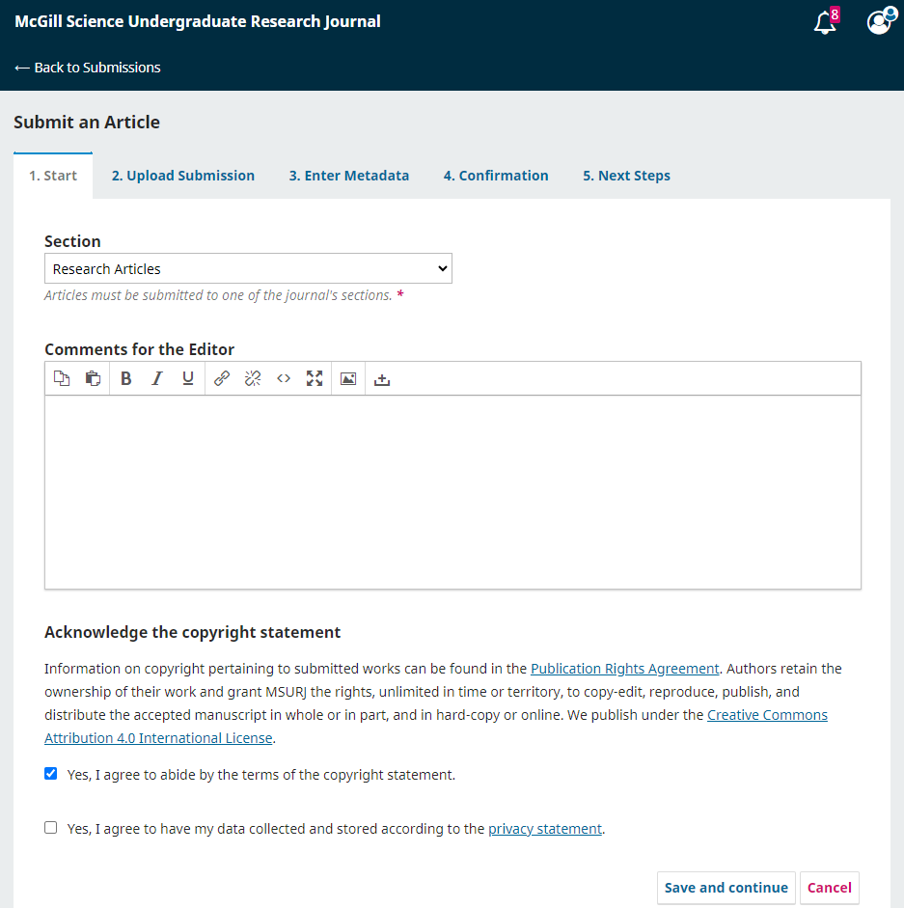

After this step is complete, you may hit “Save and Continue” to move on to Step 2.

* Step 2: Upload Submission

The second step requires you to upload your submission materials, as outlined in the Author Instructions. First, upload your file by clicking on the "Add File'' button or dragging and dropping your files. You will then be prompted by the website to specify what type of file this is, e.g. article text, supplementary material, figure, etc. This will appear as a tag next to the "Edit" and "Remove" buttons.

Make sure to upload files that are clearly labeled: each filename should include your name and a description, e.g. "Jane Doe: Manuscript". *In the image below, the files are just examples: make sure your filenames include your name.*

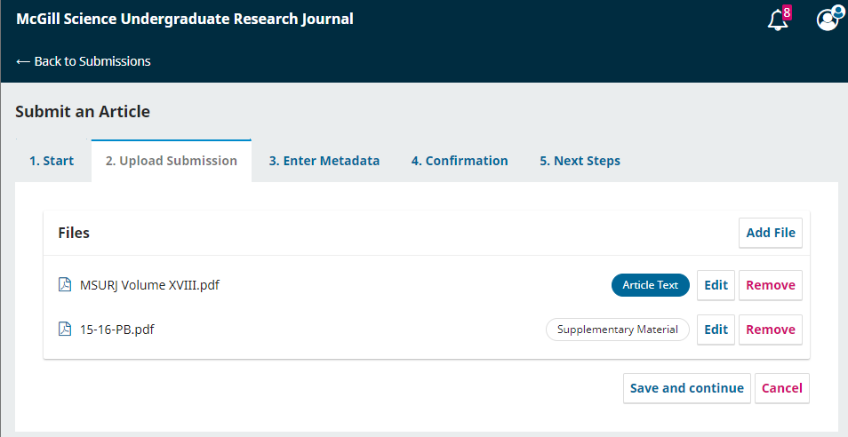

After this step is complete, you may hit “Save and Continue” to move on to Step 3

* Step 3: Enter Metadata

This is where you can enter some more information about your submission. This includes:

* Title of submission (broken down into prefix, title, and subtitle).
* Abstract
* Contributors (e.g. co-authors)

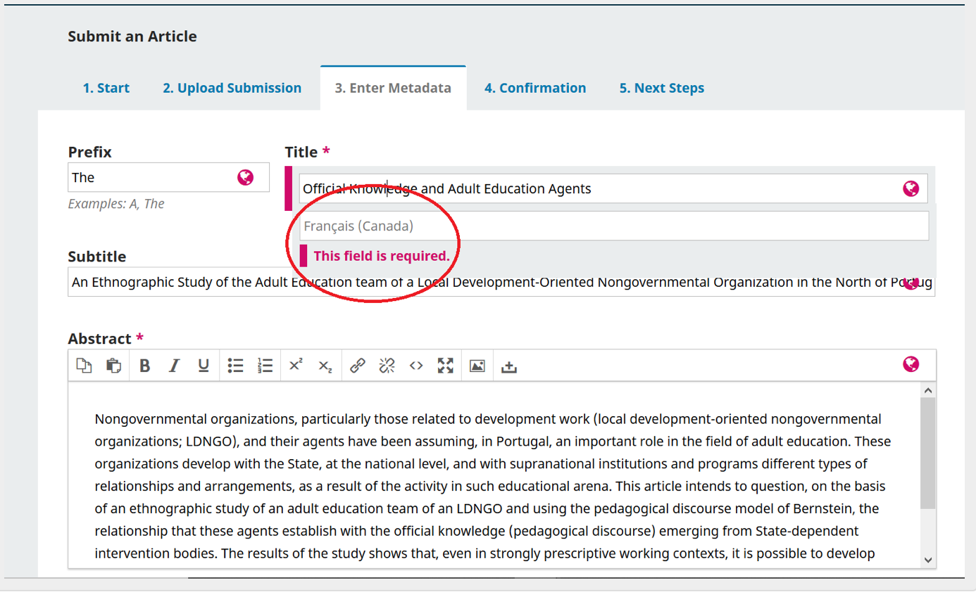

To add a list of additional contributors (i.e. co-authors), click the “Add Contributor” link. If you choose to do this, it will open a new window with fields to enter their information (i.e. name, contact, etc.). Once you hit save, the new contributor will appear on the screen.

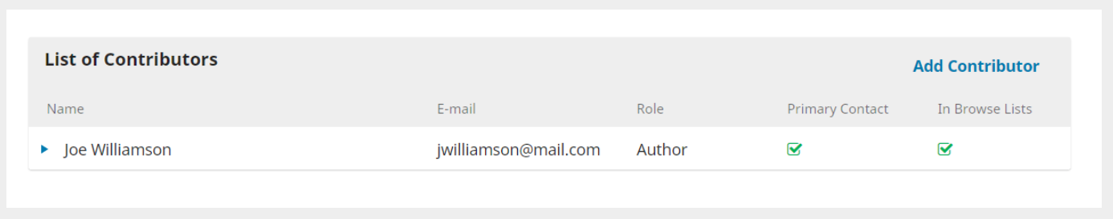

After this step is complete, you may hit “Save and Continue” to move on to Step 4.

* Step 4: Confirmation

You will be asked to confirm that you are happy with your submission. If so, click “Finish Submission.” A pop-up will ask to confirm you are done. Click “OK.”

NOTE: Once you complete and confirm your submission, you are unable to make any changes to it.

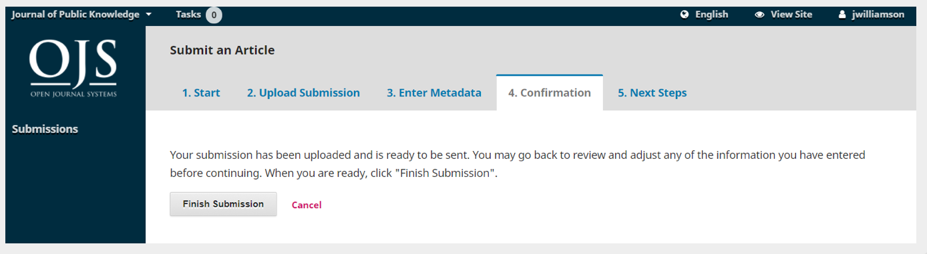

After this step is complete, you may hit “Save and Continue” to move on to Step 5.

* Step 5: Next Steps

Your submission is complete! The editorial board has been notified of your submission and you will be assigned an editor soon. At this point, you can follow the provided links to:

* Review your submission
* Create a new submission
* Return to your dashboard

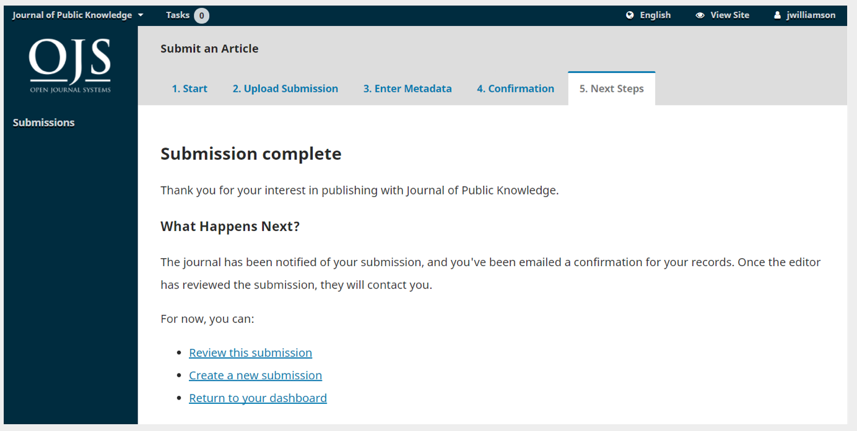

**We will be adding further instructions at a later date, guiding authors on how to use OJS for communications with editors, copyediting, reviews, etc.**